CS 1632 – DELIVERABLE 3: Web Testing with BDD

Hacker News, https://news.ycombinator.com

Evan Sheen, Neel Kowdley

We have decided to test <https://news.ycombinator.com> also known as Hacker News. The reason we decided to test this site is because it has a simple layout that isn’t dynamic. It also doesn’t have a lot of JavaScript, which would make testing hard. On top of that Hacker News isn’t a website that needs a subscription to access.

The website is a reddit like website with the ability to up vote articles or comments. There is a section that displays most recent comments on posts. Users can post articles that other logged in users can up vote. There is a new section that shows the most recently posted articles. There is a show section that shares something that a user has made on hacker news. There is also an ask section where users can ask questions to other on Hacker News and see questions that have been asked. The jobs section is a place where employers can advertise jobs that have been funded by Y combinator. Lastly there is a submit page where logged in users can submit their own posts. Conveniently on every page but the submit one you can up vote the different posts.

We choose Hacker News because of its similarity to reddit and the ease at which we could test the static elements of the website. The layout of each page is very similar which should make testing each page similar.

Some of the issues that we faced while writing tests was that the website does not document its elements very well. So testing some of the elements was difficult. We also ran into problems testing the filter by new functionality. In order to see that a post was new we needed to test its age which became complicated and we had to violate the law of Demeter in order to get the tests working. We also ran into some difficulty using the Selenium IDE add on for firefox. We also had trouble with DOM because the class’s and id’s were poorly named and sometimes indistinguishable. There were also state issues where we had to login to logout to login. Part of the issues were unforeseeable at and part of the issues were the fact the website is poorly coded and not well documented. The HTML was not put together well and the HTML driver does not work for all of our tests. Because of the nature of the website the content of the website can change rapidly and is not uniform so testing certain things such as titles can be tricky. There were also timing issues with the DOM.

Based on our experiences potential future problems would include making sure that we can handle significant UI changes without hardcoding certain variables in. Making sure that we can handle issues with the DOM in a simpler manner and not have to violate the law of Demeter in order to do so.

Our code is located at <https://github.com/eksheen/1632-Deliverable3>

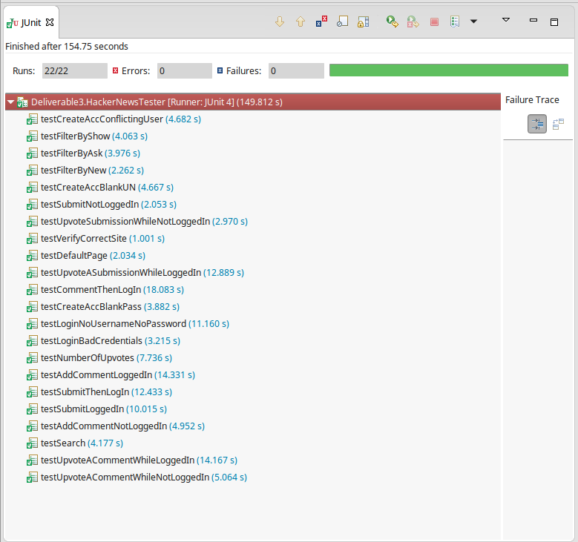

US1 As a registered user I want my account to be secure, so that I am the only one who can access it

-Given no username and a password when I try to create a new account, then I should receive an error. X

-Given no password and a username when I try to create a new account, then I should receive an error.

-Given an account with no username and no password, when I try to login, then I should receive an error. X

-Given an account with a bad username and password combo when I try to login, then I should receive an error. X

-Given a username of a preexisting account and some password combo when I try to create an account, then I should receive an error. X

US2 As a user I want to be able to vote up on comments and submissions that I find interesting so that others can see how popular the comment or submission was

-Given a comment and a valid logged in account when you upvote a comment, then the upvote should successfully occur. X

-Given a submission and a valid logged in account when you upvote a submission, then the upvote should successfully occur. X

-Given a comment and a no currently logged in account when you upvote a comment, then an error should occur X

-Given a comment and a no currently logged in account when you upvote a submission, then an error should occur X

-Given a submission, when you view a list of submissions, then you should be able to see the number of upvotes X

US3 As a registered user, I want to be able to write comments and submissions so that other users can see content that I create

-Given that a user is not logged in when they try to make a comment, then an error message should appear

-Given that a user is not logged in when they try to submit a post, then an error message should appear

-Given a user is logged in when they submit a post, then they should be able to post

-Given a user is logged in when they post a comment, then they should be able to comment.

US4 As a user of hacker news, I want to be able to view submissions by multiple categories so that I can find submissions that interest me the most

-Given a list of all submissions when new is clicked, then the first two submissions should be ordered by timestamps

-Given a list of all submissions when show is clicked, then all of the posts should have Show HN in the title

-Given a list of all submissions when asked is clicked, then at least 28 posts should have Tell, Office Hours, '?' or Ask HN:

-Given a some random word when search is pressed, then the search results page should return some results

-Given the default homepage, when a user visits the site, then every post should have a score